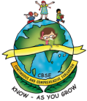
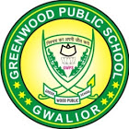
GREENWOOD PUBLIC SCHOOL
ADITYAPURAM, GWALIOR
SESSION 2023-24 : SYLLABUS FOR THE MONTH OF JANUARY : CLASS-NURSERY
SUBJECTS | SYLLABUS |  | ACTIVITY + USE OF ICT |  | PARENTS INVOLVEMENT
ENGLISH  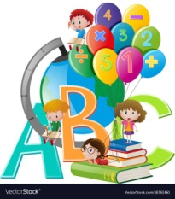  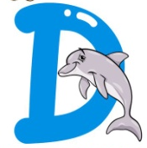  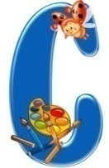  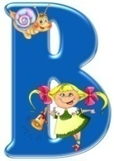  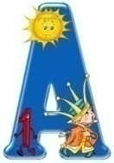 | ORAL:  Rhyme-  1. Work while you work….  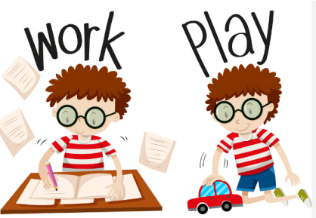  2. Yankee Doodle…  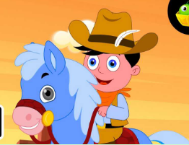  Sentence Structure-Have a nice day  Vocabulary Building-  Sweater, cap, coat, socks, shoes  Recognition- A-T  WRITTEN:  Alphabets- R-W |  | Rhyme-  1. Work while you work…  https://www.youtube.com/watch?v=X0u5DZGJkGc  2. Yankee Doodle…  https://www.youtube.com/watch?v=99BK40kXZoM  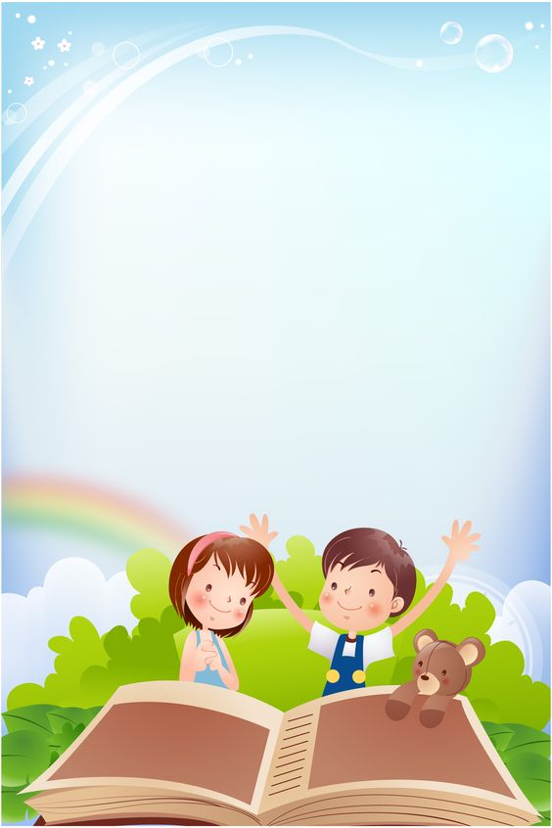  Activity Work  - Poem Recitation with actions  - ‘Show and Tell’ Picture Reading Activity |  | - Help your child in learning the rhyme.  - Motivate your child to use the vocabulary words in daily life.
SUBJECTS |  | SYLLABUS |  | ACTIVITY + USE OF ICT | PARENTS INVOLVEMENT
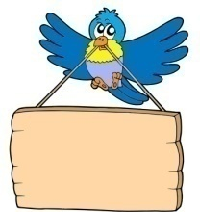  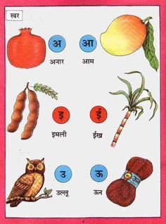  HINDI |  | ekSSf[kd%&  dfork&  1- eksph 2- ek¡ ds j[kokys  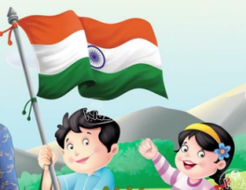  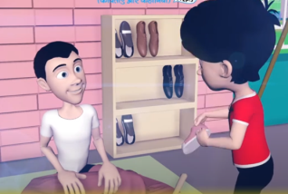  Loj o.kZ& v&v% rd  okD; jpuk& gesa lqcg tYnh mBuk pkfg,A  v{kjksa dh igpku& v& v% rd  fyf[kr lajpuk& v&v%  v{kj ys[ku& ist ua- 18 ls 26 |  | Loj o.kZekyk xhr  dfork&  1- eksph  https://www.youtube.com/watch?v=Jbr8yvPjuRw  2- ek¡ ds j[kokys  https://www.youtube.com/watch?v=v5EYF4miKbU  Activity work  - dforkvksa dks lLoj okpu  - Þns[kks vkSj crkvksaÞ [ksy ls fp=ksa dks igpkudj crk,¡A | - cPpksa dks dfork fofHkUu Hkkoksa rFkk eqnzkvksa lfgr ;kn djkus ds fy, çksRlkfgr djsaA
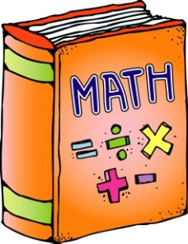 |  | 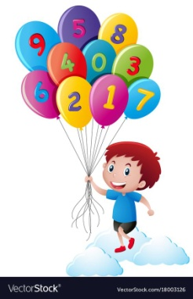  ORAL:  1. Counting from 1-50  WRITTEN: 16-20 (Numbers)  Workbook- Page no. 55-70 |  | Counting Song  https://www.youtube.com/watch?v=JT0MmZcJ2Vw  Activity Work  - Learners will be asked to count the objects asked by the educator. | - Motivate your child in counting objects  - Help your child in learning counting.

SUBJECTS | 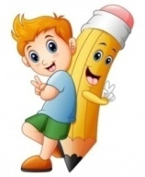  SYLLABUS | ACTIVITY + USE OF ICT | PARENTS INVOLVEMENT
ART & CRAFT | Page no. 20-25 | Activity Work  Republic Day Colour Craft | - Help your child to identify the daily life objects.
GENERAL KNOWLEDGE | 1.Indoor Games-  Ludo, Chess, Carrom, Table Tennis  2. Outdoor Games-  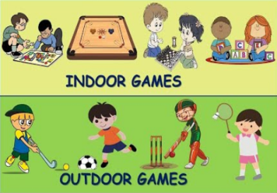  Cricket, Hockey, Football, Volleyball, Basketball | Activity Work  Colouring Activity based on GAMES. | - Play some games with your child.
VALUE EDUCATION | Greed is evil | Moral Story  https://youtube.com/watch?v=Sv5OItL7eWE&feature=shared | - Make your child learn the names of family members.
PHYSICAL EDUCATION | Atheletics Events | DO EXERCISE THROUGH THIS LINK  https://www.youtube.com/watch?v=JoF_d5sgGgc | - Take your child to a park and play some games.
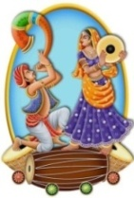  DANCE | Patriotic Song  Suno Gaur se Duniya Walo… | ‘ Suno Gaur se Duniya Walo…’ Song  https://www.youtube.com/watch?v=WhBoEaFylhg | - Help your child in participating in school activities.
MUSIC | Patriotic Song  Suno Gaur se Duniya Walo… | ‘ Suno Gaur se Duniya Walo…’ Song  https://www.youtube.com/watch?v=WhBoEaFylhg | - Help your child to learn the patriotic song.
MOTOR SKILL DEVELOPMENT | Sit on the chair,  Put on your clothes,  Sit straight,  Don’t litter,  Do not dirty your class. | REFER THIS LINK AND LEARN  Hanuman Chalisa  https://www.youtube.com/watch?v=5ua8VOH31ls | - Help your child in practicing the given skills at home.
LANGUAGE DEVELOPMENT | Important Telephone Numbers-  Police Station-100  Fire Station-101  Ambulance- 102  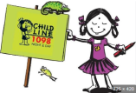  Child’s Helpline-1098 | States Capital  Madhya Pradesh Bhopal  Uttar Pradesh Lucknow  Rajasthan Jaipur  Maharashtra Mumbai | - Make your child learn the states and capitals.

SUBJECTS | SYLLABUS | ACTIVITY + USE OF ICT | PARENTS INVOLVEMENT
CONVERSATION | English Conversation  Q.1 Name the National Flag of India?  Ans. Tricolour  Q.2 How many colours are there in the Indian National Flag?  Ans. There are three colours in Indian National flag.  Q.3 What is the national song of India?  Ans- Vande Mataram  Q-4 When do we celebrate Republic Day?  Ans- We celebrate Republic Day on 26th January. | Hindi Conversation  1- gekjs jk’Vª /ot esa fdrus jax gksrs gS\  m& gekjs jk’Vª /ot esa rhu jax gksrs gSaA  2- gekjk jk’Vª xku dkSulk gSa\  m& tu x.k eu  3- gekjs jk’Vª xku dh jpuk fdlus dh\  m& gekjs jk’Vª xku dh jpuk dfo jfoanzukFk VSxksj us dhA  4- gekjs jk’Vªh; izrhd dkSu&dkSu ls gS\  m& gekjs jk’Vªh; izrhd& jk’Vª/ot] jk’Vªxku] jk’Vªxhr] jk’Vªeqnzk] vkfn gSaA | - Help your child in learning conversation questions.
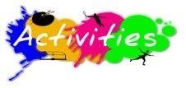 | 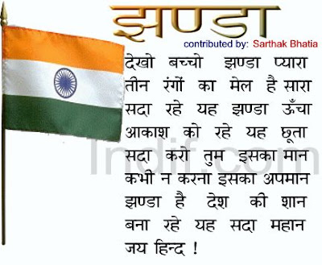  January-  Republic Day Celebration-  ‘Deshbhakti Kavita Gayan’ for Classes Nursery-UKG  on 25th January 2024, Thursday.  The assessment parameters are as follows:  - Costume (5 marks)  - Presentation (5 marks)  - Props (5 marks)  - Diction & Fluency (5 marks) |  | 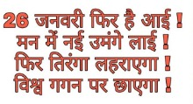  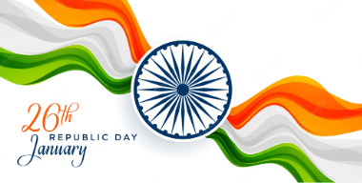
GREENWOOD PUBLIC SCHOOL
ADITYAPURAM, GWALIOR
SESSION 2023-24 : SYLLABUS FOR THE MONTH OF JANUARY : CLASS-LKG

SUBJECTS | SYLLABUS | ACTIVITY + USE OF ICT | PARENTS INVOLVEMENT
ENGLISH | ORAL:  Rhymes-  1. Hop a little, Jump a little  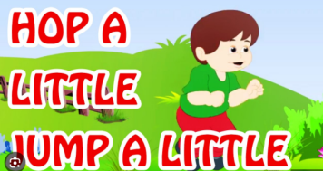  2. Two little ducks  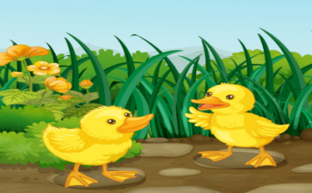  Reading-  1. Short ‘o’ and ‘u’ sound words Phonics Page no. 35, 36, 40 and 41, Use of In/on/under, Yes/No, These/Those, All about me  Vocabulary Building- Woollens, Sweater, Jacket, Blazer, Socks, Shoes  WRITTEN:  Short ‘o’ and ‘u’ sound words, Use of these/those, Use of In/On/Under, Yes/No, All about me and Colour game, Dictation, Unscramble the letters to get the correct names of the picture | Rhymes-  Hop a little, Jump a little  https://www.youtube.com/watch?v=4eKmWHuGlA8  Two little ducks  https://www.youtube.com/watch?v=434Ou7HiM2c  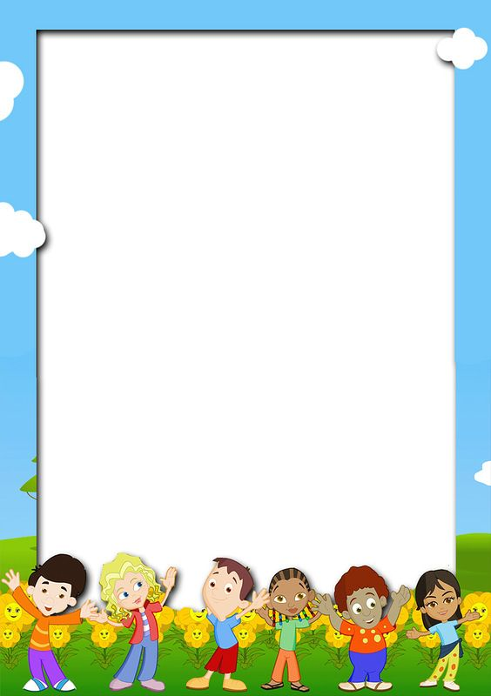  Activity Work  - ‘Look and Identify’ Game will be played for the recapitulation of the letters and their related objects. Learners will be asked to look and identify the objects as shown by the teacher.  - ‘Show and Tell’ Picture Reading Activity | - Help your child in learning rhymes.  - Motivate your child to use the vocabulary words in daily life.  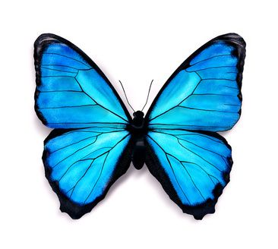
SUBJECTS | SYLLABUS | ACTIVITY + USE OF ICT | PARENTS INVOLVEMENT
HINDI | ORAL:  dfork,¡&  1- esjk >aMk 2- igsfy;k¡  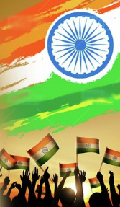  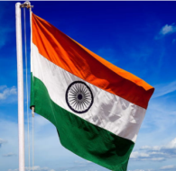  3- gekjk ns'k] gekjk oru  vkSj iqjkuh dforkvksa dk iqu% vH;kl  iBu&ikBu % nks] rhu vkSj pkj o.kksZa ls cus okD;] ,dopu] cgqopu] lfCt;ksa ds uke] fgUnh dh fxurh 1 ls 10 rd  WRITTEN:  o.kZekyk& nks] rhu vkSj pkj o.kksZa ls cus okD;] 'kCn igsyh] oxZ igsyh] nks] rhu vkSj pkj o.kksZa ls cus 'kCn] [kkyh LFkku Hkfj,] Jqrys[k ckyxhr ist ua 40] 'kCn ist ua- 69&77 | dfork,¡&  1- esjk >aMk  https://www.youtube.com/watch?v=vxlDymYJabA  2- igsfy;k¡  &  3- gekjk ns'k] gekjk oru  https://www.youtube.com/watch?v=guNyQ011wL0  o.kZekyk  https://www.youtube.com/watch?v=GBWGNvHsiFs  Activity Work  - dforkvksa dks lLoj okpu  - ns[kks vkSj crkvksaÞ [ksy ls fp=ksa dks igpkudj crk,¡A  - ^ns[kksa vkSj crkvks* [ksy ds tfj, o.kksaZ dks igpkub, ,oa crkb,sA | - cPpksa dks O;atuksa ls lacaf/kr fp=@oLrq,¡ igpkuusa esa lgk;rk djsaA  - cPpksa dks dfork fofHkUu Hkkoksa rFkk eqnzkvksa lfgr ;kn djkus ds fy, çksRlkfgr djsaA
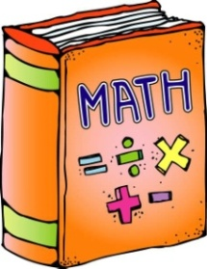 | ORAL:  Counting from 101-200, Table-2-5, Number Names 1-10, Addition Game, Subtraction and Concept of zero (0)  WRITTEN:  Counting from 151 to 200, Subtraction, Increasing and Decreasing Order, Backward Counting from 20-1, Addition Game, Dictation, Book pg no. 108-112 | Counting-  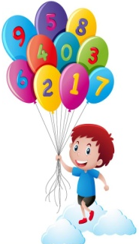  https://www.youtube.com/watch?v=B5iAW-jnkPw  Table of 5-  https://www.youtube.com/watch?v=rmQqvwlnvh8 | - Help your child in learning counting and tables.

SUBJECTS | SYLLABUS | ACTIVITY + USE OF ICT | PARENTS INVOLVEMENT
ART &  CRAFT  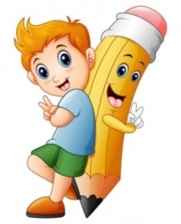 | Page no. 31-37 | Activity Work  Republic Day Colour Craft | - Help your child to identify the daily life objects.
GENERAL KNOWLEDGE | National Symbols, Different Games,  Body Parts, All about me | Activity Work  - ‘Look and Identify’ Activity based on National Symbols. | - Help your child to identify the National Symbols.  - Play some games with your child.
VALUE EDUCATION | Greed is evil | Moral Story  https://youtube.com/watch?v=ec7L5EBgJUk&feature=shared | - Make your child learn the names of family members.
PHYSICAL EDUCATION | Atheletics Events | DO EXERCISE THROUGH THIS LINK  https://www.youtube.com/watch?v=JoF_d5sgGgc | - Take your child to a park and play some games.
DANCE | Patriotic Song  Suno Gaur se Duniya Walo… | ‘ Suno Gaur se Duniya Walo…’ Song  https://www.youtube.com/watch?v=WhBoEaFylhg | - Help your child in participating in school activities.
MUSIC | Patriotic Song  Suno Gaur se Duniya Walo… | ‘ Suno Gaur se Duniya Walo…’ Song  https://www.youtube.com/watch?v=WhBoEaFylhg | - Help your child to learn the patriotic song.
MOTOR SKILL DEVELOPMENT | Sit on the chair,  Put on your clothes,  Sit straight,  Don’t litter,  Do not dirty your class. | REFER THIS LINK AND LEARN  Hanuman Chalisa  https://www.youtube.com/watch?v=5ua8VOH31ls | - Help your child in practicing the given skills at home.
LANGUAGE DEVELOPMENT | Important Telephone Numbers-  Police Station-100  Fire Station-101  Ambulance- 102  Child’s Helpline-1098 | States Capital  Madhya Pradesh Bhopal  Uttar Pradesh Lucknow  Rajasthan Jaipur  Maharashtra Mumbai | - Make your child learn the states and capitals.

SUBJECTS | SYLLABUS | ACTIVITY + USE OF ICT | PARENTS INVOLVEMENT
CONVERSATION | English Conversation  Q.1 Name the National Flag of India?  Ans. Tricolour  Q.2 How many colours are there in the Indian National Flag?  Ans. There are three colours in Indian National flag.  Q.3 What is the national song of India?  Ans- Vande Mataram  Q-4 When do we celebrate Republic Day?  Ans- We celebrate Republic Day on 26th January. | Hindi Conversation  1- gekjs jk’Vª /ot esa fdrus jax gksrs gS\  m& gekjs jk’Vª /ot esa rhu jax gksrs gSaA  2- gekjk jk’Vª xku dkSulk gSa\  m& tu x.k eu  3- gekjs jk’Vª xku dh jpuk fdlus dh\  m& gekjs jk’Vª xku dh jpuk dfo jfoanzukFk VSxksj us dhA  4- gekjs jk’Vªh; izrhd dkSu&dkSu ls gS\  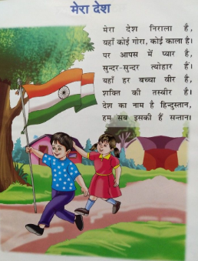  m& gekjs jk’Vªh; izrhd& jk’Vª/ot] jk’Vªxku] jk’Vªxhr] jk’Vªeqnzk] vkfn gSaA | - Help your child in learning conversation questions.
January-
Republic Day Celebration-
‘Deshbhakti Kavita Gayan’ for Classes Nursery-UKG
on 25th January 2024, Thursday.
The assessment parameters are as follows:
- Costume (5 marks)
- Presentation (5 marks)
- Props (5 marks)
- Diction & Fluency (5 marks)

GREENWOOD PUBLIC SCHOOL
ADITYAPURAM, GWALIOR
SESSION 2023-24 : SYLLABUS FOR THE MONTH OF JANUARY : CLASS-UKG
SUBJECTS | SYLLABUS | ACTIVITY + USE OF ICT | PARENTS INVOLVEMENT
ENGLISH | ORAL:  Rhymes-  1. Popcorn  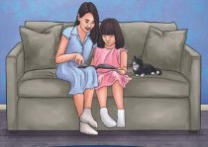  2.My mother  Vocabulary Building-  Genders- Male-Female, Father-Mother, Lion-Lioness, King-Queen, Uncle-Aunt, Bull-Cow  Reading Pg No.- 24,30,32,37,39  WRITTEN:  Genders, Use of ‘What is this/that?’, Yes-No, Use of ‘I am’, ‘You are’,  Use of ‘We are’, ‘They are’  Use of ‘Our’, ‘Their’  Use of ‘on, in, under, behind, in front of and near’,  Use of where, how many | Rhymes-  1. Popcorn  https://www.youtube.com/watch?v=n8EbspwvB2I  2.My mother  https://www.youtube.com/watch?v=-BV0plNPUeQ  Activity Work  - Learners will be asked to use on/in/under/behind/in front of/near in the sentences given by the teacher. | - Help your child in learning rhymes.  - Help your child in learning genders.

SUBJECTS | SYLLABUS | ACTIVITY + USE OF ICT | PARENTS INVOLVEMENT
HINDI | dfork,¡&  1- g¡ldj cksyks 2-esjh xqfM+;k  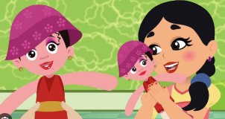  iBu ikBu& ist u. 95] 97] 99  fyf[kr%&  ikB&27% j ¼jsQ½ dh ek=k ¼ ` ½  ikB&28% j ¼insu½ dh ek=k ¼ z ] ª ½  v{kjksa dk vk/kk :i  lIrkg ds fnu] L=h&iq:’k] fyax] esjk ifjp; | 1- g¡ldj cksyks  https://www.youtube.com/watch?v=XRsVgtndZ8I  2-esjh xqfM+;k  https://www.youtube.com/watch?v=TG7hp79BYEY  Activity Work  - dforkvksa dks lLoj okpu  - ns[kks vkSj crkvksaÞ [ksy ls fp=ksa dks igpkudj crk,¡A  - ^ns[kksa vkSj crkvks* [ksy ds tfj, v¡ dh ek=k  okys 'kCnksa dks if<+, ,oa crkb,sA | - cPpksa dks dfork fofHkUu Hkkoksa rFkk eqnzkvksa lfgr ;kn djkus ds fy, çksRlkfgr djsaA
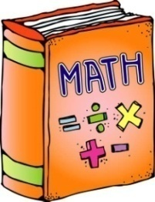  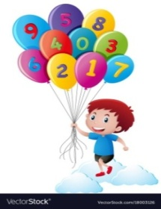 | ORAL:  1. Counting from 401-500  2. Tables from 2 to10  3. Number names from 51 to 100  4. Days of the Week  WRITTEN:  Counting from 401 to 500  Number names from 81 to 100  Table of 10,  Money,  Subtraction with ‘0’,  Days of the week | Counting-  https://www.youtube.com/watch?v=B5iAW-jnkPw  Number Names  https://www.youtube.com/watch?v=LyvQ6pc7JSA  Activity Work  - ‘Look and Identify’ Number Names Game  - Table Quiz- Dodging will be taken up. | - Help your child in learning counting and tables.

SUBJECTS | SYLLABUS | ACTIVITY + USE OF ICT | PARENTS INVOLVEMENT
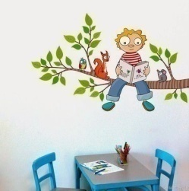  EVS | ORAL:  Land Transport- Bus, Car, Train, Bicyle, Scooter  Water Transport- Boat, Ship, Yacht  Air Transport- Aeroplane, Helicopter, Rocket  Flowers- Rose. Sun flower, Lotus, Lily, Marigold  Leaves- Banana Leaf, Peepal Leaf, Mango Leaf, Papaya Leaf, Neem Leaf  WRITTEN:  Means of Transport; Our Earth; Air, Water and Weather; Our Sky; Outdoor Games | - | - Make your child learn the various means of transport.
ART & CRAFT | Page no. 21, 22, 23, 24  (Butterfly, Joker, Vegetables, Air Balloon) | Activity Work  Republic Day Colour Craft | - Help your child to identify the daily life objects.
GENERAL KNOWLEDGE | Vehicles, In the Park, Toys | Activity Work  Learners will speak two lines on  his/her favourite toy. | - Help your child identify the vehicles, things in the park
VALUE EDUCATION | Greed is evil | Moral Story  https://youtube.com/watch?v=ec7L5EBgJUk&feature=shared | - Make your child learn the names of family members.
PHYSICAL EDUCATION | Atheletics Events | DO EXERCISE THROUGH THIS LINK  https://www.youtube.com/watch?v=JoF_d5sgGgc | - Take your child to a park and play some games.
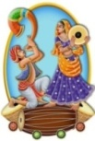  DANCE | Patriotic Song  Suno Gaur se Duniya Walo… | ‘ Suno Gaur se Duniya Walo…’ Song  https://www.youtube.com/watch?v=WhBoEaFylhg | - Help your child in participating in school activities.
MUSIC | Patriotic Song  Suno Gaur se Duniya Walo… | ‘ Suno Gaur se Duniya Walo…’ Song  https://www.youtube.com/watch?v=WhBoEaFylhg | - Help your child to learn the patriotic song.
MOTOR SKILL DEVELOPMENT | Sit on the chair,  Put on your clothes,  Sit straight,  Don’t litter,  Do not dirty your class. | REFER THIS LINK AND LEARN  Hanuman Chalisa  https://www.youtube.com/watch?v=5ua8VOH31ls | - Help your child in practicing the given skills at home.
LANGUAGE DEVELOPMENT | Important Telephone Numbers-  Police Station-100  Fire Station-101  Ambulance- 102  Child’s Helpline-1098 | States Capital  Madhya Pradesh Bhopal  Uttar Pradesh Lucknow  Rajasthan Jaipur  Maharashtra Mumbai | - Make your child learn the states and capitals.

SUBJECTS | SYLLABUS | ACTIVITY + USE OF ICT | PARENTS INVOLVEMENT
CONVERSATION | English Conversation  Q.1 Name the National Flag of India?  Ans. Tricolour  Q.2 How many colours are there in the Indian National Flag?  Ans. There are three colours in Indian National flag.  Q.3 What is the national song of India?  Ans- Vande Mataram  Q-4 When do we celebrate Republic Day?  Ans- We celebrate Republic Day on 26th January. | Hindi Conversation  1- gekjs jk’Vª /ot esa fdrus jax gksrs gS\  m& gekjs jk’Vª /ot esa rhu jax gksrs gSaA  2- gekjk jk’Vª xku dkSulk gSa\  m& tu x.k eu  3- gekjs jk’Vª xku dh jpuk fdlus dh\  m& gekjs jk’Vª xku dh jpuk dfo jfoanzukFk VSxksj us dhA  4- gekjs jk’Vªh; izrhd dkSu&dkSu ls gS\  m& gekjs jk’Vªh; izrhd& jk’Vª/ot] jk’Vªxku] jk’Vªxhr] jk’Vªeqnzk] vkfn gSaA | - Help your child in learning conversation questions.
January-
Republic Day Celebration-
‘Deshbhakti Kavita Gayan’ for Classes Nursery-UKG
on 25th January 2024, Thursday.
The assessment parameters are as follows:
- Costume (5 marks)
- Presentation (5 marks)
- Props (5 marks)
- Diction & Fluency (5 marks)

